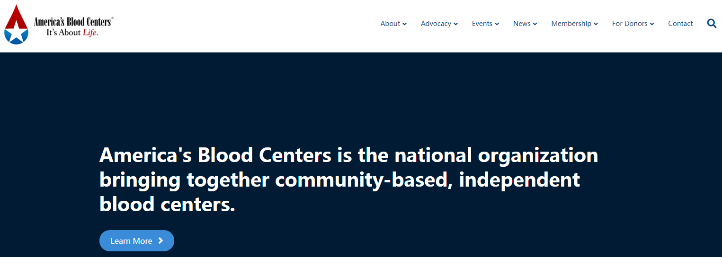
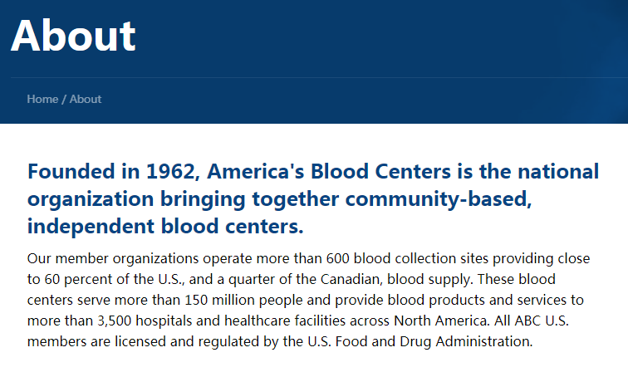
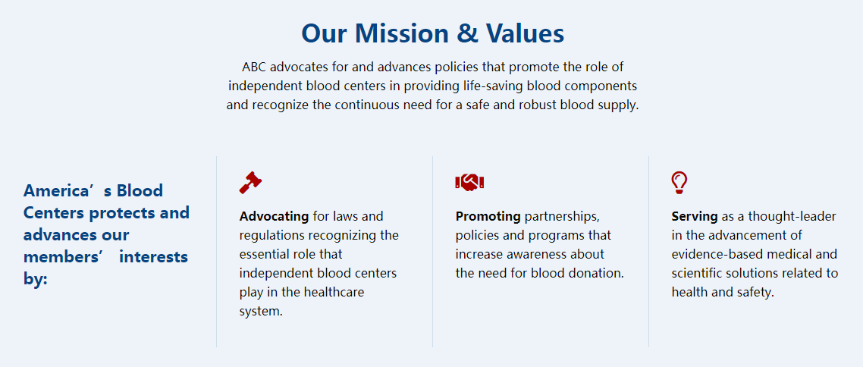

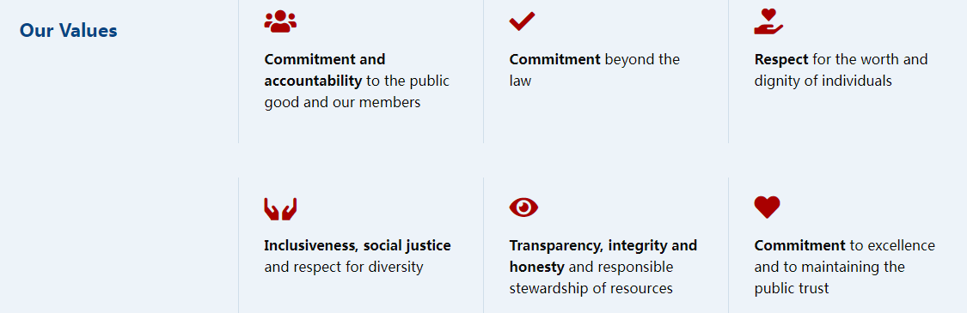

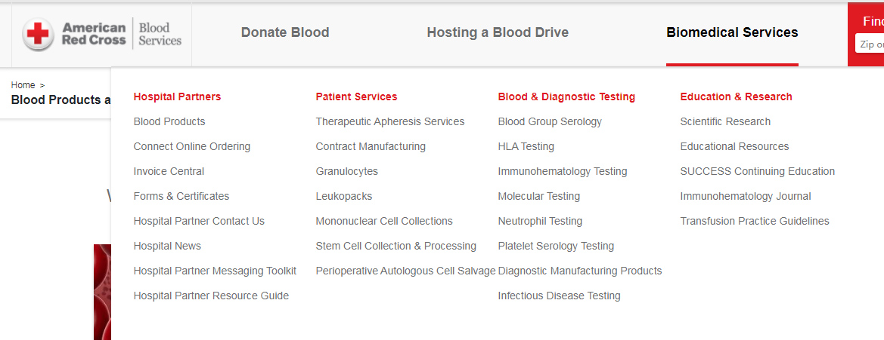

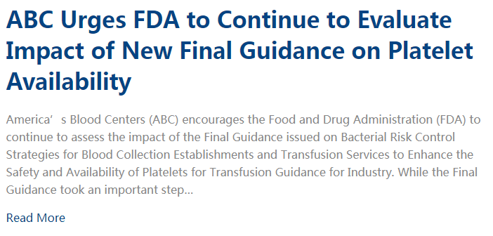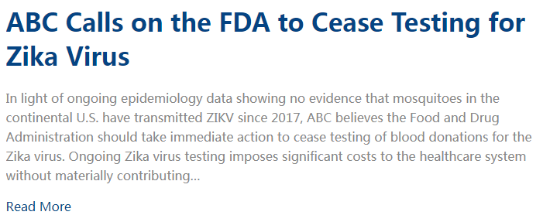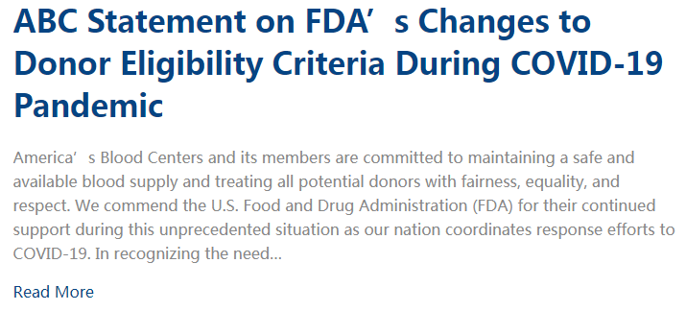

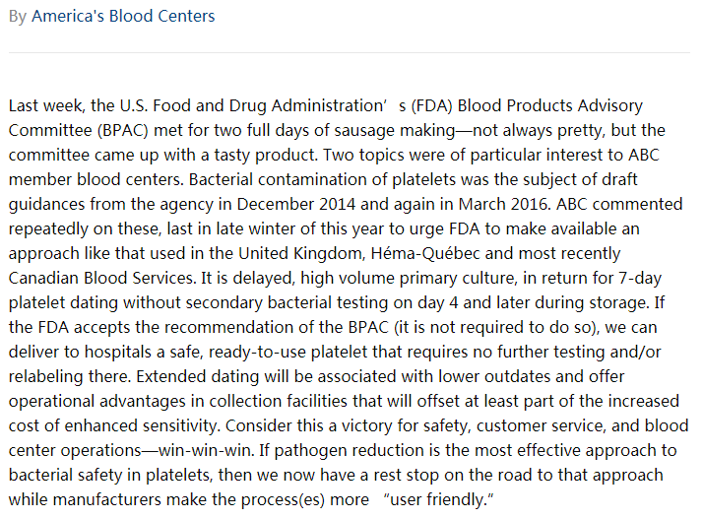

The Blood Donor app:
Schedule and Manage Appointments
Find local blood drives and donation centers quickly and easily right from the palm of your hand. The app makes scheduling and rescheduling appointments easy and convenient.
Save Time With RapidPass®
RapidPass® can help save time during your donation. For the best donation experience, we recommend you schedule an appointment on the app, then complete your RapidPass®.
View Donation History & Health Vitals
Keep track of total blood donations, review your mini physical results, and even access your COVID-19 antibody test results.
Track Your Blood Journey
Follow your blood donation's journey every step of the way as it makes its way to a hospital to help patients in need.
Earn Achievement Badges
Celebrate your donation milestones with friends & family.

